CS7641 Problem Set 2 solutions

**Problem Set 2 Solutions**

1. A is twice as frequent than B or C. So we can represent A with 1 bit, B and C with 2 bits. Expected message size is 1 x P(A) + 2 x P(B) + 2 x P(C) = 1.5 bits

2. EM algorithm finds a gaussian mixture model (GMM) that best fits the data. The k-means procedure is a special case of GMM when you don’t consider variances between samples. In fact a variance of k-means, called the Lloyd algorithm, is essentially EM algorithm using a centroid model.

3.

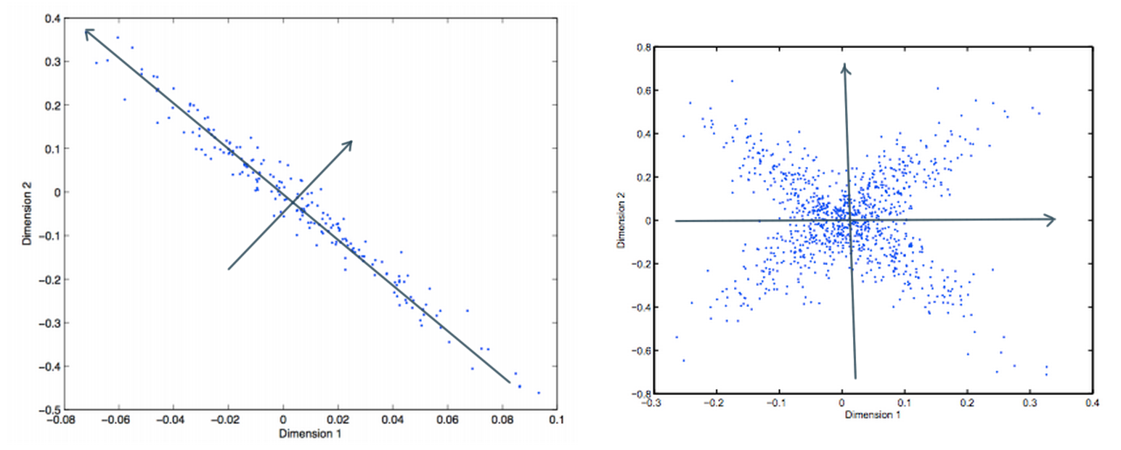

In the second figure, the diagonal is not an axis because, it can be used to best separate only one of the spreads and not the other.

4. a. Hierarchical clustering with single link is most likely to well. GMM can also produce a decision boundary that can produce such clustering result, but depending on initialization it might converge to a different set of clusters (left half vs. right half). Other hierarchical clusterings won’t really work well because at some point, two intermediate clusters from different true cluster will have shorter cluster distance than two from the same true cluster.  
  
b. K-means or GMM is most likely. Hierarchical clustering wouldn’t work since the early few steps will group instances near the decision boundary (note some of them are very close).  
  
c. Among the ﬁve methods, only GMM has the capability of handling overlapping clusters. So GMM is the only method that would result in such clusters.

6.

For total exploration,

Q(s, a1) = 2.5

Q(s, a2) = 2.25

For greedy exploration,

Q(s, a1) = 2.5

Q(s, a2) = 3.0

7. Draw the MDP

Value function for each state is below:

**Iteration 0**

|  |  |  |
| --- | --- | --- |
| 0.00 | 0.00 | 0.00 |
| 0.00 | 0.00 | 0.00 |
| 0.00 | 0.00 | G |

**Iteration 1**

|  |  |  |
| --- | --- | --- |
| 0.00 | 0.00 | 0.00 |
| 0.00 | 0.00 | 10.0 |
| 0.00 | 10.0 | G |

**Iteration 2**

|  |  |  |
| --- | --- | --- |
| 0.00 | 0.00 | 8.0 |
| 0.00 | 8.0 | 10.0 |
| 8.0 | 10.0 | G |

**Iteration 3**

|  |  |  |
| --- | --- | --- |
| 0.00 | 6.4 | 8.0 |
| 6.4 | 8.0 | 10.0 |
| 8.0 | 10.0 | G |

**Iteration 4**

|  |  |  |
| --- | --- | --- |
| 5.12 | 6.40 | 8.0 |
| 6.40 | 8.0 | 10.0 |
| 8.0 | 10.0 | G |

8.

To find the Nash equilibria, we examine each action profile in turn.  
(*A*,*B*) Neither player can increase her payoff by choosing an action different from her current one. Thus this action profile is a Nash equilibrium.  
(*A*,*B*) By choosing *B* rather than *A*, player 1 obtains a payoff of 1 rather than 0, **given** player 2's action. Thus this action profile is not a Nash equilibrium. [Also, player 2 can increase her payoff by choosing *A* rather than *B*.]  
(*B*,*A*) By choosing *A* rather than *B*, player 1 obtains a payoff of 2 rather than 0, **given** player 2's action. Thus this action profile is not a Nash equilibrium. [Also, player 2 can increase her payoff by choosing *B* rather than *A*.]  
(*B*,*B*) Neither player can increase her payoff by choosing an action different from her current one. Thus this action profile is a Nash equilibrium.  
We conclude that the game has two Nash equilibria, (*A*,*A*) and (*B*,*B*).

To find the Nash equilibria, we examine each action profile in turn.

(*A*,*A*) Firm 2 can increase its payoff from 1 to 2 by choosing the action *B* rather than the action *A*. Thus this action profile is not a Nash equilibrium.

(*A*,*B*) Firm 1 can increase its payoff from 1 to 2 by choosing the action *B* rather than the action *A*. Thus this action profile is not a Nash equilibrium.

(*B*,*A*) Firm 1 can increase its payoff from 1 to 2 by choosing the action *A* rather than the action *B*. Thus this action profile is not a Nash equilibrium.

(*B*,*B*) Firm 2 can increase its payoff from 1 to 2 by choosing the action *A* rather than the action *B*. Thus this action profile is not a Nash equilibrium.

We conclude that the game has no Nash equilibrium!

For the last problem,

(*T*,*L*) Neither player can increase its payoff by choosing a different action, so this action profile is a Nash equilibrium.

(*T*,*R*) Player 1 can increase her payoff from 0 to 1 by choosing the action *B* rather than the action *T*. Thus this action profile is not a Nash equilibrium.

(*B*,*L*) Firm 1 can increase its payoff from 0 to 2 by choosing the action *T* rather than the action *B*. Thus this action profile is not a Nash equilibrium.

(*B*,*R*) Neither firm can increase its payoff by choosing a different action, so this action profile is a Nash equilibrium.

We conclude that the game has two Nash equilibria, (*T*,*L*) and (*B*,*R*).

Published by [Google Drive](https://docs.google.com/)–[Report Abuse](https://docs.google.com/abuse?id=1mAWqri6Bxmt8FVSfOjUI163H84ldoLPHvHrls3Pukok)–Updated automatically every 5 minutes